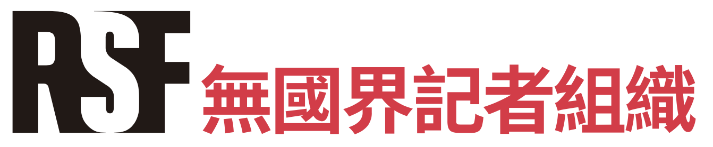

新聞稿

2023年10月26日

總統大選競選活動日漸升溫，NGO聯盟邀請媒體承諾恪守新聞倫理
隨著台灣大選的競選活動日漸升溫，NGO聯盟們今天發起「 新聞倫理誓言」活動，以期提升大眾對媒體的信任。聯盟將於2023 年 11 月 9 日舉行的記者會上公布首批簽署承諾的媒體。
台灣 2024 年大選的競選活動日漸升溫，民主進程受不實資訊攻擊的潛在威脅不容小覷。理想上，民眾在網路上看到可疑的「假新聞」時應主動前往名聲良好的媒體仔細確認看到的資訊，但在現實中，台灣媒體界卻常因政治兩極化、煽情報導、利益衝突，被批評違反新聞倫理。根據牛津大學的路透新聞學機構，台灣民眾對媒體的信任度只有28%，在民主國家裡幾近吊車尾。
事實上台灣有越來越多媒體意識到自己所承擔的責任，也願意對大眾負責。為展示最佳實踐的榜樣，並鼓勵各界積極推動倫理性報導，無國界記者 、公民參與媒體改造聯盟與台灣媒體觀察教育基金會組成非政府組織聯盟，在台灣新聞記者協會和全國傳播媒體產業工會的支持下，於今天發起「台灣選舉新聞倫理誓言」活動。
聯盟呼籲抵制操縱性訊息
台灣媒體觀察教育基金會表示：「國際調查受假訊息、假新聞影響之國家，台灣總是榜上有名且名列前茅。這和台灣特殊的國際政治處境有關。若台灣的媒體不經妥善查證，將網路流傳的假訊息寫成了假新聞，將會對台灣民主社會造成巨大且難以挽救的傷害。因此，在總統大選期間，我們需要再次以行動倡議新聞倫理準則的重要性，鼓勵媒體自主簽署NGO聯盟提出的五大倫理原則，確保媒體不會淪為惡意假訊息的推手。」
無國界記者亞太辦事處執行長艾瑋昂表示：「民主要培養對不實資訊的天然免疫力，唯一的永續方案就是恪守新聞倫理：在操縱性的訊息蔓延之前就加以過濾，並提供值得信賴的內容作為替代。」他進一步解釋：「當記者有足夠的時間和資源來遵守最高倫理標準，當編輯部門有能力拒絕商業和政治壓力時，公眾對媒體的信任自然會提高，對受到操縱性的訊息也會置若罔聞。」
公民參與媒體改造聯盟表示：「媒體在進行相關報導時，都應注意事實查證並注意公平原則，且總統大選相關報導多數涉及公共利益，依五大倫理原則進行報導，能將新聞內容客觀呈現於公眾，有助於公共利益之增進。本次很榮幸受邀與無國界記者組織、台灣媒體觀察教育基金會一同組成NGO聯盟進行倡議，期盼媒體能一同對五大倫理原則進行支持。」
五大倫理原則
聯盟邀請台灣媒體公開承諾遵守五大倫理原則：公平報導、準確報導、專業語調、尊重隱私、公開透明。
- 公平報導：媒體承諾提供受眾平衡之選舉活動新聞報導，並為各政黨及候選人提供其計畫介紹與觀點表達之均等空間。
- 準確報導：媒體承諾確保所有報導資訊之真實性及準確性。對候選人及其支持者之主張進行系統性事實查核，並明確區分其為事實或意見。

- 專業語調：媒體承諾避免使用可能誤導受眾之煽情與煽動性語言，並儘可能謹慎評論民意調查及選舉結果。
- 尊重隱私：媒體承諾尊重候選人及其家人之隱私權。除非相關資訊涉及公眾基本利益，否則應避免非必要之侵犯其個人空間。
- 公開透明：媒體承諾如實說明調查方法，披露任何可能影響報導之利益衝突或傾向。

歡迎所有媒體加入

只要是同意採取具體措施在編輯部門內部加強尊重新聞倫理的台灣媒體，都歡迎加入活動。

參與活動的媒體將可標榜為媒體改造聯盟、無國界記者與媒體觀察基金會「台灣選舉新聞倫理誓言」簽署者。

NGO聯盟將於2023 年 11 月 9 日早上在台北舉辦記者會，公布參與活動的首批簽署者。

網站: RSFTaiwan.org/Pledge

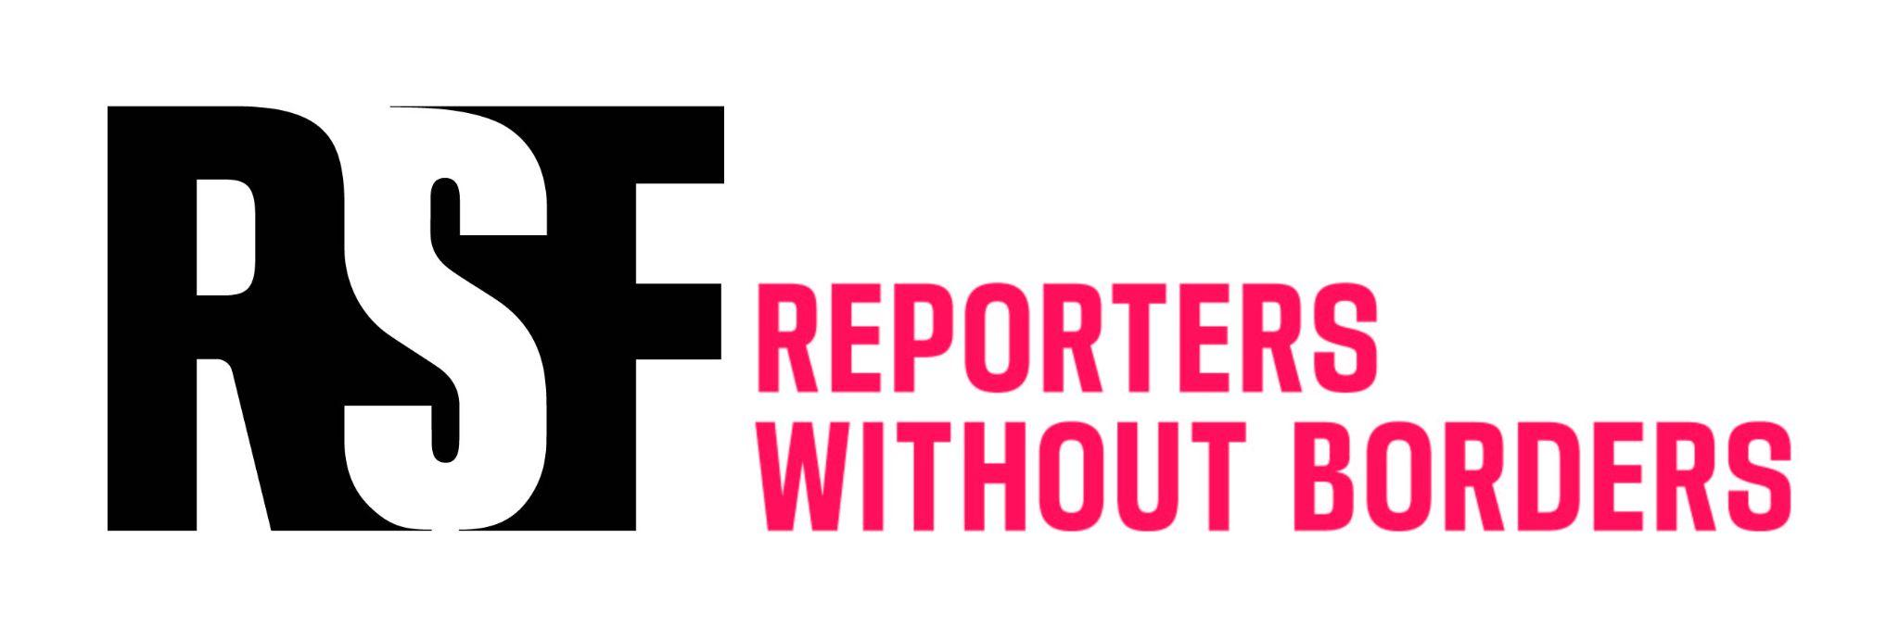

PRESS RELEASE

26 October 2023

As election campaign heats up, NGO coalition invites media to commit to journalism ethics

As the Taiwanese election campaign heats up, an NGO coalition today launched the “Ethical Journalism Pledge for Taiwan Elections”, an initiative aimed at boosting public trust in the media. A press conference will be organised on 9 November 2023 to present the first wave of signatories to the pledge.

As the 2024 general election campaign heats up in Taiwan, the threat of potential disinformation attacks impacting the democratic process cannot be underestimated. In an ideal world, when confronted with suspected “fake news” online, the public should turn to reputable media outlets in order to double-check the information. But the Taiwanese media community itself is often criticised for breaching journalism ethics due to political polarisation, sensationalism, and conflicts of interest. Taiwan suffers from one of the lowest rates of public trust in the media among democracies: only 28% according to the Oxford Reuters Institute.

However, a growing number of Taiwanese media outlets are aware of the responsibility they bear, and willing to be accountable to the public. In order to showcase these best practices and encourage more positive steps towards ethical reporting, an NGO coalition composed of Citizen Campaign for Media Reform (CCMR), Reporters Without Borders (RSF) and Taiwan Media Watch Foundation (TMWF), and supported by the Association of Taiwan Journalists (ATJ) and Taiwan Media Workers Union (TMWU), have launched “The Ethical Journalism Pledge for Taiwan Elections” today.

A call to combat disinformation

“Due to Taiwan’s peculiar geo-political circumstances, Taiwan is one of the most exposed countries to disinformation campaigns,” states Taiwan Media Watch Foundation. “To combat disinformation, the role of the journalism community of Taiwan is front and centre. Taiwan’s fair election relies on the journalism community to disseminate accurate and newsworthy information to the public. Our NGO coalition is taking action to emphasise the importance of ethical journalism during the election season. We encourage media outlets to pledge their commitment to the five ethical journalism guidelines.”

“Ethical journalism is the only sustainable mechanism for a democracy to develop a natural immunity against disinformation,” says Cédric Alviani, Reporters Without Borders (RSF) Asia-Pacific Bureau Director. “When the media community better filters manipulative content before it becomes viral, public trust in the media will naturally improve and ‘fake news’ will fall on deaf ears.”

“Media outlets should pay due diligence in their fact checking, and be fair to all candidates, when reporting on the general election," asserts Citizen Campaign for Media Reform (CCMR). “Reports should respect the five journalism ethical guidelines to present objective information to the public, and to promote the public interest. We are honoured to be invited to the initiative and form a coalition with Reporters Without Borders (RSF) and Taiwan Media Watch Foundation (TMWF). We invite media outlets to commit to the five ethical guidelines.”

Five ethical guidelines

The NGOs invites Taiwanese media outlets to publicly pledge respect for five basic ethical guidelines: fair coverage, accurate reporting, professional tone, respect for privacy, and transparency.
- Fair coverage: The media outlets pledge to provide audiences with balanced news coverage on the election campaign and provide equal space for each party and candidate to present their programmes and express their views.

- Accurate reporting: The media outlets pledge to ensure the veracity and precision of all information reported, systematically fact-check claims made by candidates and their supporters, and clearly separate facts from opinions.

- Professional tone: The media outlets pledge to avoid sensational and inflammatory language that may mislead audiences and exercise utmost caution when commenting on polls and electoral results.

- Respect for privacy: The media outlets pledge to respect the candidates’ and their families’ right to privacy and avoid unnecessarily infringing upon their personal space, except when the information is of essential interest to the public.

- Transparency: The media outlets pledge to show utmost transparency regarding their investigation methods and disclose any possible conflicts of interest or predisposition that could influence reporting.

All media outlets welcome

Every Taiwan-based media is welcome to join the initiative, providing they commit to take concrete measures to enforce better respect for journalism ethics within their editorial department.

Media outlets that are part of the initiative will be allowed to refer themselves as a “Signatory of the Ethical Journalism Pledge for Taiwan Elections initiated by Citizen Campaign for Media Reform (CCMR), Reporters Without Borders (RSF) and Taiwan Media Watch Foundation (TMWF) with the support of the Association of Taiwan Journalists (ATJ) and Taiwan Media Workers Union (TMWU).”

On the morning of 9 November 2023, the NGO coalition will organise a press conference in Taipei in order to present the first wave of signatories to the pledge.

Webpage: RSFTaiwan.org/Pledge

